DIS-AM,C-Taino-Zemi Head

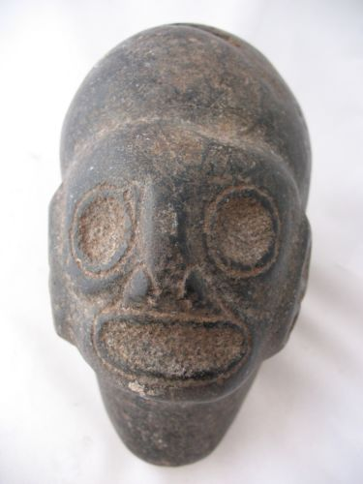

5 pounds and 8 ounces. It is approx. 6” long and approx. 4 and 3/4” tall and approx. 3.5” wide.

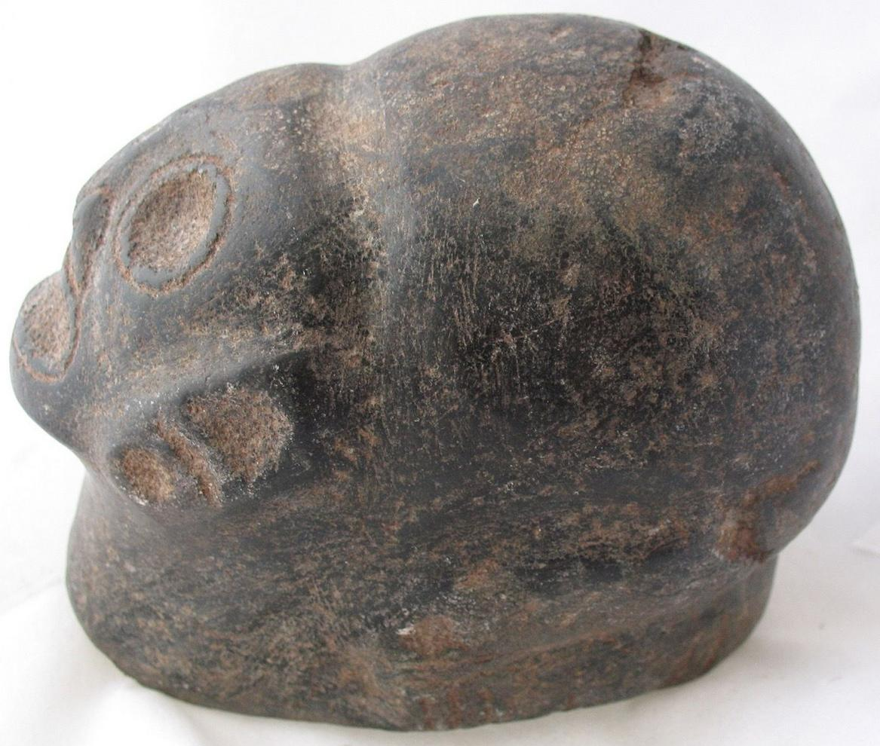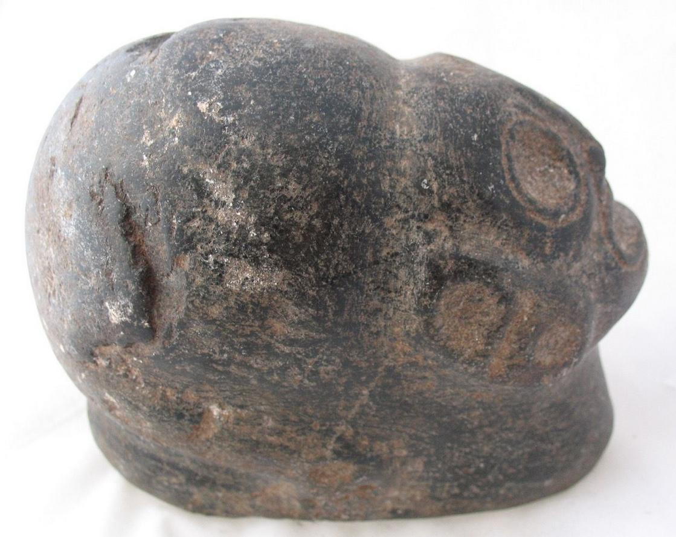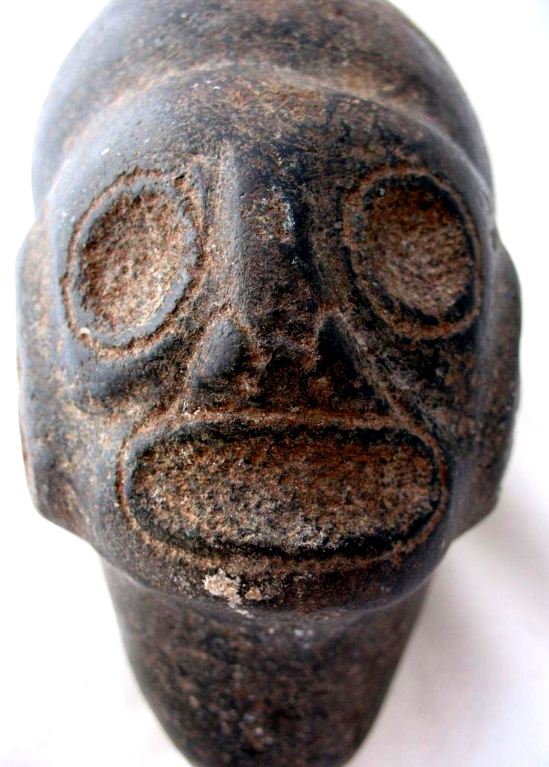

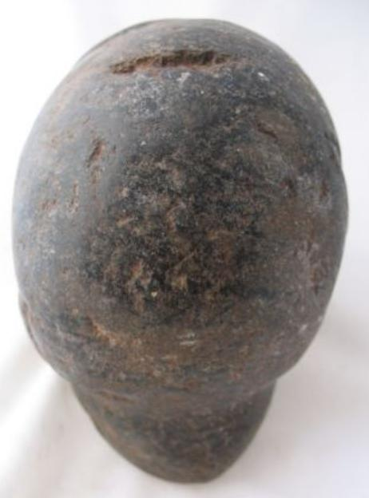

|  |
| --- |
| Winning bid:  US $271.00  [ [23 bids](http://offer.ebay.com/ws/eBayISAPI.dll?ViewBids&item=201433870820&rt=nc&_trksid=p2047675.l2565) ] |
| Shipping:  $15.00 Expedited Shipping |
| Item location:  Fort Lauderdale, Florida, United States |